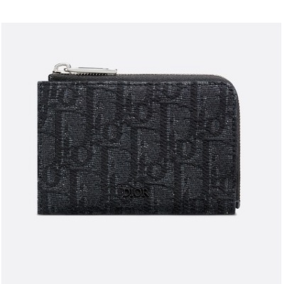

Dior Oblique wallet

PRODUCT DETAILS

**Rubber "Dior" signature on the outside**

**Heat-embossed "Dior" signature on the inside**

**2 compartments for bills and receipts**

**1 card slot on the outside**

**Made in Italy**

**12 x 8 cm**